Please join the Commonwealth Chamber of Commerce Hong Kong for a webinar on
Commonwealth Social Enterprises in Hong Kong.

Join our webinar and have the opportunity to join the Commonwealth Chamber Hong Kong for 12 months free of charge!

About the Webinar

The webinar takes place on 8th November 2021 (Monday) at 6 pm Hong Kong time.

Social enterprises (SEs) play a major role in supporting underprivileged groups, tackling social problems via commercial means, and building a community of harmony through the provision of community services in Hong Kong. According to the Social Enterprise Business Centre (SEBC) and the British Council, as of April 2021, Hong Kong has 659 registered SEs, although the actual number may be up to 5,700. These enterprises come in a variety of forms ranging from NGOs and NPOs to private businesses and traditional charities.

Many of the most well-known and most innovative social enterprises have been set up or operated by leaders or representatives of Hong Kong’s diverse ethnic minorities, often with strong Commonwealth affiliations. Although 70 per cent of these SEs having less than 10 employees and less than half of the total SEs are breaking even, they have persevered in the face of the pandemic with a 16 per cent increase in SEs recorded post-2019.

This webinar invites four stellar leading figures in this field who will share their experiences and deep-dive into the challenges faced by these enterprises, providing insight on the opportunities for the business community of Hong Kong looking to support them.

Introduction

Ms Julia Charlton, Chairman, Commonwealth Chamber of Commerce HK: Julia is the founding and managing partner of Charltons, an award-winning Hong Kong corporate finance law firm. Julia is admitted as a solicitor in Hong Kong, England, Wales and the BVI. She practises in the field of corporate finance, including M&A, private equity, securities, virtual assets and funds.

Julia is a member of the Commonwealth Enterprise & Investment Council (CWEIC)’s Global Advisory Council. With her family, Julia founded and runs the Asia Education Foundation, providing funding to university students who may otherwise have to drop out due to hardship, and the Asia Environment Foundation which had included efforts for disaster relief. As a member of the HKEX Listing Committee, Julia organised an annual sponsored hiking event, Hike for Hong Kong, the proceedings of which went to fund volunteer projects at HandsOn Hong Kong.

Moderator

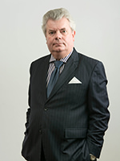
Mr Andrew Wells, General-Secretary, Commonwealth Chamber of Commerce HK: Mr Andrew Wells is Chairman of China Golden Bridge Group, a family company with interests in public services and real estate consultancy; financial services and M&A; and hospitality and green development.

He is a former scholar of King’s College Cambridge. After working in Palestine, India and Iran, he joined the Administrative Service in Hong Kong in 1978. His roles included Deputy Secretary to the Executive and Legislative Councils, Secretary to the Hong Kong Education Commission, Founding Director of the Hong Kong Open University, and Deputy Secretary for Trade and Industry, Finance and Housing.

After retiring from the Government in 2003, Andrew worked as a senior executive in Lai Sun Development, a listed property group. He also served as the Chief Secretary and Acting Governor of three British Overseas Territories from 2008 to 2011. In January 2021, Andrew was appointed Secretary-General of the new Commonwealth Chamber of Commerce in Hong Kong, whose mission is to strengthen business ties between Hong Kong and Commonwealth enterprises.

Andrew was a long-standing member of the Real Estate Developers Association of Hong Kong and is a Fellow of the Hong Kong Institute of Directors. His roles in the Hong Kong General Chamber of Commerce include Vice Chairmanship of the Asia Africa Committee, membership of the Europe and Real Estate and Infrastructure Committees and membership of the Belt and Road Initiative and Sustainable Finance Working Groups.

Panellists

Mrs Geetanjali Dhar:
Chairwoman, The Women Entrepreneurs Network; Founder & Director, Sanskriti Global Group; Co-founder & Chairwoman, Integrated Brilliant Education Ltd.

With over three decades of rich experience as an entrepreneur, an educator and an equality & inclusion advocate, Geetanjali Dhar is committed to enhancing existing pedagogies in the field of language learning via her organisation Sanskriti Global. She has created unique benchmarking standards in the field of education and is constantly looking at value additions in the learning experiences of her students. The organisations she founded conduct programs for schools and universities across multiple regions (Singapore, India, and Hong Kong). As a hospitality master trainer, she also lends her expertise to the hospitality industry of Hong Kong.

As the Co-founder and Chairwoman of the Integrated Brilliant Education (IBEL), a
registered Hong Kong charity that enjoys a formidable reputation for its stellar
work, Geetanjali is involved in formulating innovative solutions to the pressing social
issues among the underserved population in Hong Kong. Geetanjali Dhar was elected as the Chairwoman of the board of directors at Women Entrepreneurs Network Hong Kong on 1 June 2021 and looks forward to providing a range of new benefits for WEN members.

Geetanjali has received numerous awards in recognition of her outstanding work including ‘Woman of Influence Award’ by the American Chamber of Commerce Hong Kong in 2019;
‘Pioneering Women Leader’ at World Woman Leadership Congress in Mumbai and Hong Kong’s Women Leaders award in Hong Kong 2018.

Mr Manoj Dhar:
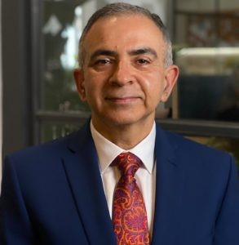
CEO& Co-founder, IBEL (Integrated Brilliant Education Trust); Winner, SCMP Classified Post HR Appreciation Award; Finalist and winner, Operation Santa Claus UBS NGO Leadership Programme.

With over 21 years of rich and varied experience in the risk and compliance banking industry, Manoj Dhar decided to become a social innovator, lending his meticulous organizational skills to oversee the growth of various educational initiatives in Hong Kong. He was acknowledged for his work by receiving the Covid 19 Special NGO Award by SCMP for his NGO that operated throughout the pandemic and social unrest with sustained operations of two centres, zero layoffs, and no pay cuts.

As the Chief Executive Officer of ‘Integrated Brilliant Education Trust’, he is extensively involved in implementing Chinese language support initiatives for the underprivileged ethnic minority children in Hong Kong. He firmly believes in empowering the children with practical life skills so that they can seamlessly integrate into the social fabric of Hong Kong.

Manoj is a sports enthusiast and devotes a lot of his organizational expertise in developing and managing the women’s team at a premier Rugby Club in Hong
Kong.

Mr Innocent Mutanga:
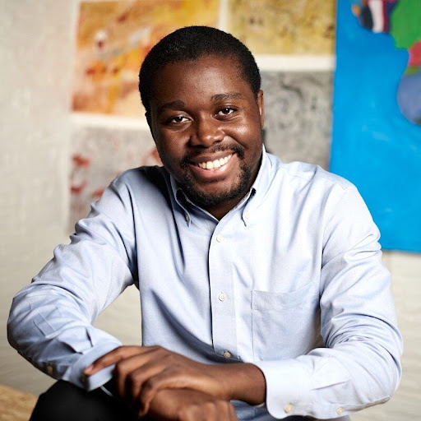
CEO and Co-Founder, Hong Kong African Center.

At the age of 21, Mutanga fled Zimbabwe in 2013 and became the first African refugee to graduate from a Hong Kong University, earning his degree in Anthropology from the Chinese University of Hong Kong with a fascinating focus on the interaction between hedge funds and the “moral economy”. He currently works as an analyst at a major investment bank.

Besides his immaculate academic achievements and career, Mr Mutanga is very active in the social enterprise scene in Hong Kong, being the co-founder of Wandering Voices, a public engagement platform dedicated to increasing trust between minority communities and those on the mainstream through media, and also Lerato Hong Kong an initiative dedicated to providing access to education to refugees and asylum seekers in Hong Kong.

As a well-known speaker and community leader, he is a strong advocate of the value of businesses in driving international and Commonwealth relations.

Mr Neville Shroff, JP:

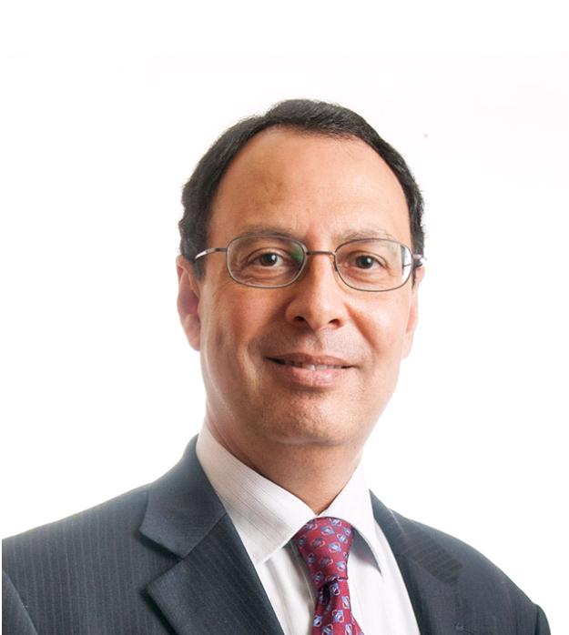
President, Parsee Zoroastrian Charity Funds of Hong Kong, Canton and Macao; President, Zoroastrian Parsee Association of Hong Kong; Chairman, Global Working Group of Leaders of the Zoroastrian Parsee Community; Director, World Zoroastrian Chamber of Commerce.

As Chairman and CEO of Shroff and Company Ltd., Mr Shroff has expansive experience in Hong Kong trading specifically in sourcing, quality control, logistics and commodity shipping services. He is also the Chairman of Direct International Hong Kong Ltd, a company that exports mainly fashion garments and branded goods. His knowledge of the economy of Hong Kong makes him an indispensable member of the General Committee of the Hong Kong General Chamber of Commerce and the Hong Kong Housing Society.

Besides trading, Mr Shroff has achieved numerous exceptional milestones in philanthropic endeavours; he is the Director of The Hong Kong Tuberculosis, Chest & Heart Diseases Association and is a key member of the Ruttonjee and Tang Shiu Kin Hospital Governing Board. He also serves as a Board member of the English Schools Foundation.

For his splendid efforts and achievements in both economics and humanitarian endeavours, he was awarded the title of Justice of Peace by the Hong Kong Government in 2015.

